Project

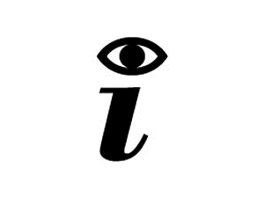TEST

Problem Statement

In today society mankind is constantly using digital devices, that are affecting, negatively, vision health. It's been a concern for the past years to fight this era’s side-effect. To get yourself diagnosed, you must go to a doctor, which in public healthcare means a long wait and sometimes may be costly.

The Project’s goal is to design a tool to help diagnose irregularities in human vision, such as astigmatism, near-sightedness, and colour blindness. With only one device the user will be able to self-diagnose in an interactive and fast way.

We will have a screen showing images, that the user must identify. The device will recognise the answer and evaluate it. In the end of the test it will give you a result of how good or not your vision is.

**Grupo 6:**

Fábio Magalhães – A75030

Rui Carvalho – A76279